**Computer Networks – LAB 4: Addressing and Subnetting (VLSM) with Cisco Packet Tracer**

**Objective:**

* To configure a network using Variable Length Subnet Masking (VLSM) to optimize IP address utilization.
* To design and implement subnets of different sizes based on network requirements.
* To configure routers and PCs with the appropriate IP addresses and subnet masks.
* To simulate and verify end-to-end connectivity within the network using Cisco Packet Tracer.

**Requirements:**

* Cisco Packet Tracer software.
* A GitHub account and a repository for lab assignments.
* Access to Google Classroom for submission

**Procedure:**

Network Design and Subnetting:

1. Design the network topology:

* Determine the IP address requirements for each subnet.
* Calculate the subnet addresses using VLSM.

Step 1: Subnetting the Network

1. Identify the major network address:

* Example: 192.168.0.0/24

2. Determine the number of subnets and their sizes:

* Subnet 1 (e.g., 50 hosts): Network Address: 192.168.0.0/26 (Subnet Mask: 255.255.255.192)
* Subnet 2 (e.g., 30 hosts): Network Address: 192.168.0.64/27 (Subnet Mask: 255.255.255.224)
* Subnet 3 (e.g., 10 hosts): Network Address: 192.168.0.96/28 (Subnet Mask: 255.255.255.240)
* Subnet 4 (e.g., 5 hosts): Network Address: 192.168.0.112/29 (Subnet Mask: 255.255.255.248)

Step 2: Configuring Router1

1. Select the router and open CLI.

2. Press ENTER to start configuring Router1.

3. Activate privileged mode:

* Type enable

4. Access the configuration menu:

* Type config t (configure terminal)

5. Configure interfaces of Router1:

○ FastEthernet0/0:

* Type interface FastEthernet0/0
* Configure with the IP address 192.168.0.1 and Subnet mask 255.255.255.192

○ FastEthernet0/1:

* Type interface FastEthernet0/1
* Configure with the IP address 192.168.0.65 and Subnet mask 255.255.255.224

6. Finish configuration:

* Type no shutdown to activate the interfaces

Step 3: Configuring PCs

1. Assign IP addresses to each PC:

○ PC0:

■ Go to the desktop, select IP Configuration, and assign the following:

■ IP address: 192.168.0.2

■ Subnet Mask: 255.255.255.192

■ Default Gateway: 192.168.0.1

○ PC1:

■ Go to the desktop, select IP Configuration, and assign the following:

■ IP address: 192.168.0.66

■ Subnet Mask: 255.255.255.224

■ Default Gateway: 192.168.0.65

Step 4: Connecting PCs with Router

1. Connect the devices using copper straight-through cables:

* Connect FastEthernet0 port of PC0 to FastEthernet0/0 port of Router1
* Connect FastEthernet0 port of PC1 to FastEthernet0/1 port of Router1

Configuration Tables

Simulation of Designed Network Topology

Sending a PDU from PC0 to PC1

1. Open the simulation mode in Packet Tracer.

2. Send a PDU from PC0 to PC1:

* Observe the packet traveling from PC0 to the router and then to PC1.

Acknowledgment from PC1 to PC0

1. Observe the acknowledgment packet:

* Ensure that the acknowledgment packet travels back from PC1 to PC0, confirming successful communication.

**Results:** 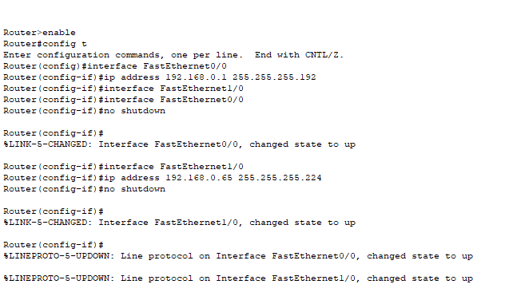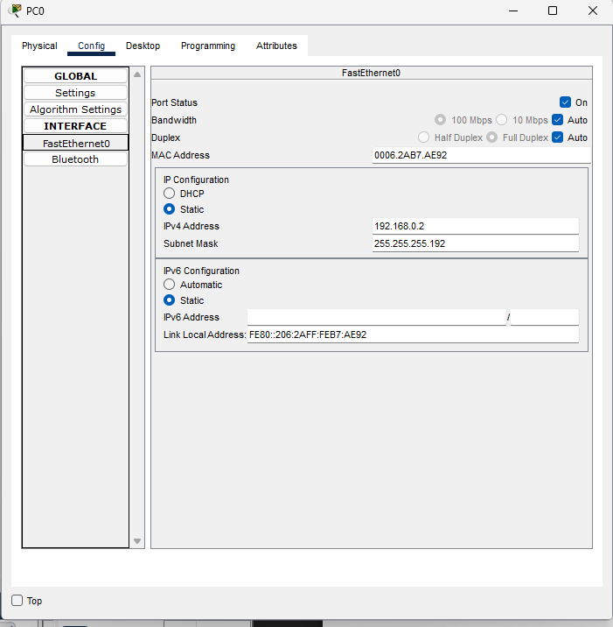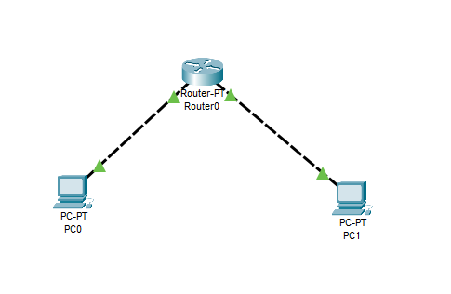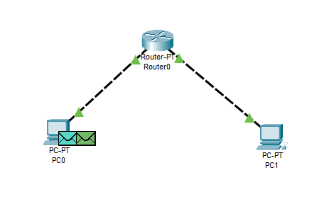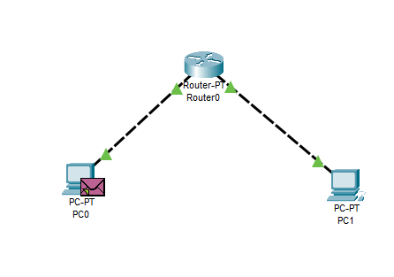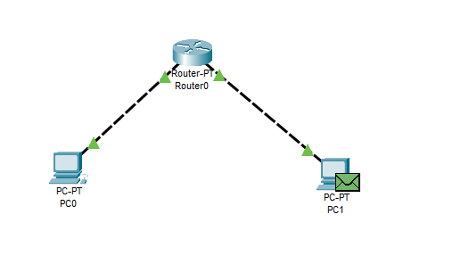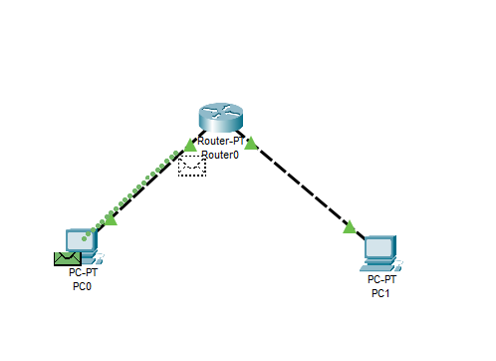

**Conclusions:**

In this experiment, we successfully demonstrated the use of Variable Length Subnet Masking (VLSM) to create an efficient network design by optimizing IP address allocation. By configuring routers and PCs with appropriate IP addresses and subnet masks, we established a functional network topology with subnets of varying sizes tailored to specific requirements. The simulation in Cisco Packet Tracer verified that the network was correctly configured, enabling smooth and successful communication between devices. This exercise reinforced the importance of VLSM in managing IP address space efficiently, particularly in networks with diverse size requirements.